Iteration 1

In our initial development cycle, the first "sprint," our Coders-Boot team focused on developing the City Cravings website. Named after the name of a restaurant chain that is expanding, City Cravings serves various South Asian cuisines. The foods served are part of cuisines from India, Nepal, Tibet, and Bangladesh. The user's focus of this sprint was to define the basic structure of the site, which includes the homepage, an order page where users can browse for and select the food, and the login page. These pages were created keeping end-use customer experience in mind, revolving around making the order process as easy as possible, while offering additional satisfaction.  
  
The website is to serve customers ordering food online from modest Carneyland. In this sprint, they have the ability to view a menu; register or log in to actuate their e-commerce accounts; and add items to online shopping carts that represent a pre-purchase phase so that customers may avail online ordering process after the exercise and payment. The groundwork has been laid to implement staff-centric features within the following sprinting phases. Staff will be able to view incoming orders from this feature eventually, as well as manage the menu and update order statuses. However, for now, customer-facing features were by far the main focal point of the cycle of exercise. Our system-enforcing business rules clearly prescribe a customer-facing page and personal-profile access only to customers, while staff have bulky access to the secure backend to make business work. These convenient control measures have directed design choices and feature planning for the present sprint.

Rules of Business – First Iteration

Following are business rules pertaining to which persons are eligible to access the City Cravings web application and what it allows them to do for the first pass-through. These rules hold good for making and securing the system logically for customers and staff.

1. User Access and Roles

a. Customer

Customers are users of the website. They will be able to:

Get into the home page, or gallery, to see the restaurant and features.

New applicants can get registered or log in using a secured form.

After log-in, they can order food by selecting various items from the menus.

Finally, they can see the total amount for their purchase before confirming.

Order page can only be accessed by the logged-in customers.

b. Restaurant Staff

It is true that there is no complete operation for that yet. However, staff users still belong to part of the system structure and will definitely have access, sometime in the future. For now,

Staff information in the database is for future support of admin or management access.

Roles like Admin, Kitchen Staff have been defined but not yet operational.

2. Ordering Rules

An order can be placed only by a customer who has logged in.

An order can only be placed with at least one menu item (though its details are not stored individually for now).

The order must be saved with its total amount, date and time, and order status-FOR EXAMPLE, pending.

Once the order has been placed, it will be automatically associated with the customer who placed it.

In case of duplicate orders, this system would never allow duplicate orders unless that was an intentional act.

3. Visibility and Availability of Menu

All menu items are visible for any user visiting the homepage or order page.

Each menu item has an “available” status; If a dish is marked "unavailable," it shall not be displayed in the ordering interface.

Items should be grouped based on cuisine, for example, Indian, Nepali, Tibetan, and Bangladeshi to help the users navigate better.

4. Data Integrity and Privacy

User passwords are stored in a hashed format for security.

Email addresses must be unique: Users cannot register the same email with two different accounts.

All client information is stored securely and is used solely for the purpose of order processing and system identification.

Staff and customers will have different access levels depending on their roles.

5. System Constraints (for this iteration)

Payments are not considered in this version-your orders are placed without online payment.

There is no tracking of orders in real time.

Customers cannot change or cancel an order after it has been submitted.

Working together as a team, the tasks were delivered in this iteration. **Yulesh Mahat** developed the entire front-end code to ensure the pages are responsive, functional, and visually sound. **Puspanjali Thapa** and **Md Maidul Islam Rahat** concentrated on UI/UX design by creating wireframes and mockups, giving shapes to the visual identity for the site. **Aarekshya Dc** has worked on database design with MySQL which made sure all the crucial data (like customer details and orders) can be stored whenever needed for retrieval purposes. **Sulav Pokhrel** helped in deploying and hosting the application on renders and making the work online for further examination. Despite not using Jira for our project tracking, we kept our task tracking on sticky notes and weekly meetings, where we assigned responsibilities to the developers and took the required report of the daily progress, to keep our work on track throughout the iteration cycle, hence ensuring meeting crucial set deadlines.

The site's visual design took a green theme that echoed a feeling of freshness—the right branding for a restaurant that serves freshly prepared cooked meals. The layout is very simple and clean and invites seamless user engagement. Irish Grover, Bubbles, and Ubuntu typefaces are good to combine for type. Irish Grover and Bubbles remain playful, amicable at and wide headings, while Ubuntu Typewriter is the sans-serif selection for general content, as it is polished enough for very quick readability. So that was all a way of ensuring the site you see has a friendlier perspective with a modern touch that serves City Cravings identity.

Database design

The database system developed uses MySQL. It also includes numerous tables granting the current operation. The most pivotal entities of the system now are customers, menu items, orders, order details, and staff. Customer tables are used to store details like names, email, and passwords. The menu items table contains information about the dishes like their names, prices, categories, and descriptions. Orders and their details are connected through foreign keys to allow customers to receive a view of the ordered items with their prices and total amounts. This application also creates a staff table for management of staff available, to be utilized in the backend management system. These key relations create continuity and organization that should get further harnessed in future iterations.

**Buyers and Purchases**

Every customer signing in to the City Cravings website gets a customer entry in the customers' table. This holds their name, email, password, contact details and delivery address. When a customer places an order, a new row is created in the orders table. That order record references back to the customer through the customer_id. Thus, it is clear that you know which customer has placed an order.

So the relationship here is: one customer can place many orders. But one order belongs to one customer.

**Menu Items and Orders**

All your food dishes are stored in the menu_items table, like chicken curry, momo, biryani, etc. It contains their name, price, and short description and which cuisine they belong to (like Indian or Nepali). It also has a field pertaining to whether they are available.

When customers make an order, the only thing that resides in the orders table is the total amount of the order, time and date it was placed. The order_detail table is not part of the schema anymore; therefore, it is safe to assume that individual food items ordered are not stored in the database. For the time being, the system records that "an order's placed" and its total price without showing what items were in that order.

That's perfectly acceptable for a basic version, particularly early on in development. But you might want to consider it useful to add order_details later if you plan to develop that further. (for instance, kitchen seeing what the items were exactly ordered).

**Staff and Orders**

The staff's table is to be meant for the restaurant team who has the access to manage the system. Each employee has its own log-in details assigned with specific roles, like admin, chef, or delivery person. While they will not place an order, they will be able to view an order, update it and mark it given the continued development. Currently, the orders table does possess a status field so that later a staff member could change the status of an order from "pending" to "preparing" or "delivered".

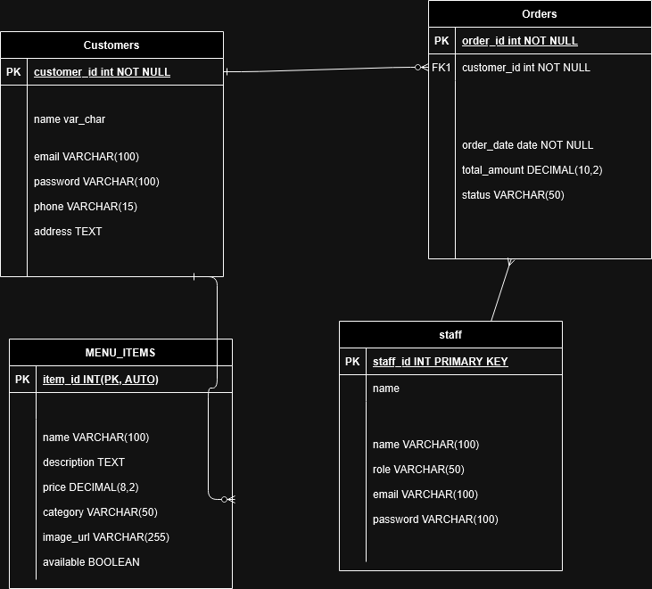

Visual Design

And this is a process that would be important at this moment, if City Cravings had to be designed anew all over again at the very first iteration. It focuses on everything that is necessary for a food ordering experience-simple, clear, and approachable. The layout is still comprehensive, as was the current trend in UI design today-and acutely more interesting since it is effectively usable even on the very first visit, the first-time visitor hoping against hope that this generation has fast-paced ordering.

Not just for its beauty, this green-themed palette in color scheme has been chosen for association with freshness and appetite-ultimately important factors in a restaurant context. From headings through buttons to highlights, the many shades of green run like a true-colored thread, towards a coherent and appetizing interface.

Typography was selected with the objective of keeping nuclear but playful. The chief typeface is Irish Grover, Bubbles, and Ubuntu. All the three fonts were tested for readability-withesthetical balance. Irish Grover and Bubbles bring in warm welcoming tones to the headings and central text areas, whereas Ubuntu sharpens and professionalizes the body text. While this set also isn't a common one, it adds a tinge of charm and personality that suits it well for a local multicultural restaurant like City Cravings.

The current homepage showcases a solid call to action section for users to check out their order, along with a short sponsorship of the types of cuisines offered- Indian, Nepali, Bangladeshi, and Tibetan. A huge grid layout with images enables a quick view of food offerings.

The focus is placed on the login page with the virtually distraction-free white space that works towards directing the user's attention to form fields and their associated guidance text. On the other side, there is a strict step-by-step guidance on the order page that moves from choosing the dishes to the order confirmation, all framed into an order page. It is optimized to feel familiar and frictionless by integrating many features already established by food delivery sites while City Cravings spices things up with colors and type.

We built the design thoroughly by ensuring maximum responsiveness for all views-wouldn't be adopting any WordPress themes and drag-and-drop builders. Indeed, any layout will change suitably, without compromising on readability and usability.

Basically, Iteration 1 was about setting up a foundation: Design was created and its functionality seen into. This enabled a strong foundation on which succeeding epochs could be built upon.